- Inbound EDI contains:

- ETA
- VESSEL NAME

Remarks: To allow Inbound CS to have an overview on these information. Similar to Outbound Booking Info

- Pick List

Remarks: To insert additional column – <Country Labeling?>

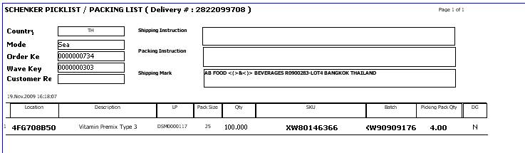

- Packing Module

Remarks: To allow system packer to enter the total # of country labels used in the particular Delivery Note. This information will be reflected in the shipment booking summary under the Total Labeling column as shown below.

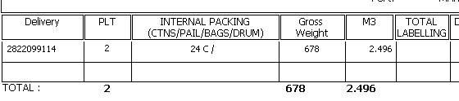

- Outbound EDIs

  - 2 incidents of EDI not being able to receive. Outbound CS had to call IT to retrieve EDI.

Remarks: To have an overview of EDIs received. i.e 12noon & 5.30pm

